**CITY OF GRAND JUNCTION**

#### ORDINANCE NO. 4563

#### AN ORDINANCE VACATING THE KIRBY SUBDIVISION PLAT, RIGHT-OF-WAY FOR CLAIRE DRIVE AND PORTIONS OF UTILITY, IRRIGATION, AND DRAINAGE EASEMENTS

#### LOCATED 2856 B 3/4 ROAD

RECITALS:

The property owner and the City of Grand Junction have requested vacation of the Kirby Subdivision plat and portions of the rights-of-way and Utility, Irrigation and Drainage easements dedicated thereon.

The City Council finds that the request is consistent with the Comprehensive Plan, the Grand Valley Circulation Plan and Sections 21.02.090 and 21.02.100 of the Grand Junction Municipal Code.

The Planning Commission, having heard and considered the request and found the criteria of the Code to have been met, recommends that the vacations be approved.

NOW, THEREFORE BE IT ORDAINED BY THE CITY COUNCIL OF THE CITY OF GRAND JUNCTION THAT:

The following described subdivision plat and rights-of-way dedicated thereon are hereby vacated subject to the following:

1. Excepting 5’ of the right-of-way for B 3/4 Road adjacent to the property and excepting the 10’ wide perimeter utility, irrigation and drainage easements along the north, west and east property lines, which the City shall retain on behalf of the public.

The Kirby Subdivision Plat is shown on “Exhibit A”.

Legal description:

A certain parcel of land lying in the Northwest Quarter of the Northeast Quarter (NW 1/4 NE 1/4) of Section 30, Township 1 South, Range 1 East of the Ute Principal Meridian, County of Mesa, State of Colorado and being more particularly described as follows:

ALL of Kirby Subdivision, as same is recorded in Plat Book 11, Page 28, Public Records of Mesa County, Colorado lying North of a line 25.00 feet North of and parallel with the South line of the NW 1/4 NE 1/4 of said Section 30;

With the exception of the above-described right-of-way and easements to be retained by the City on behalf of the public.

INTRODUCED for first reading on this 5th day of December, 2012 and ordered published in pamphlet form.

PASSED and ADOPTED on second reading this 19th day of December, 2012 and ordered published in pamphlet form.

ATTEST:

/s/: Bill Pitts

President of City Council

/s/: Stephanie Tuin

City Clerk

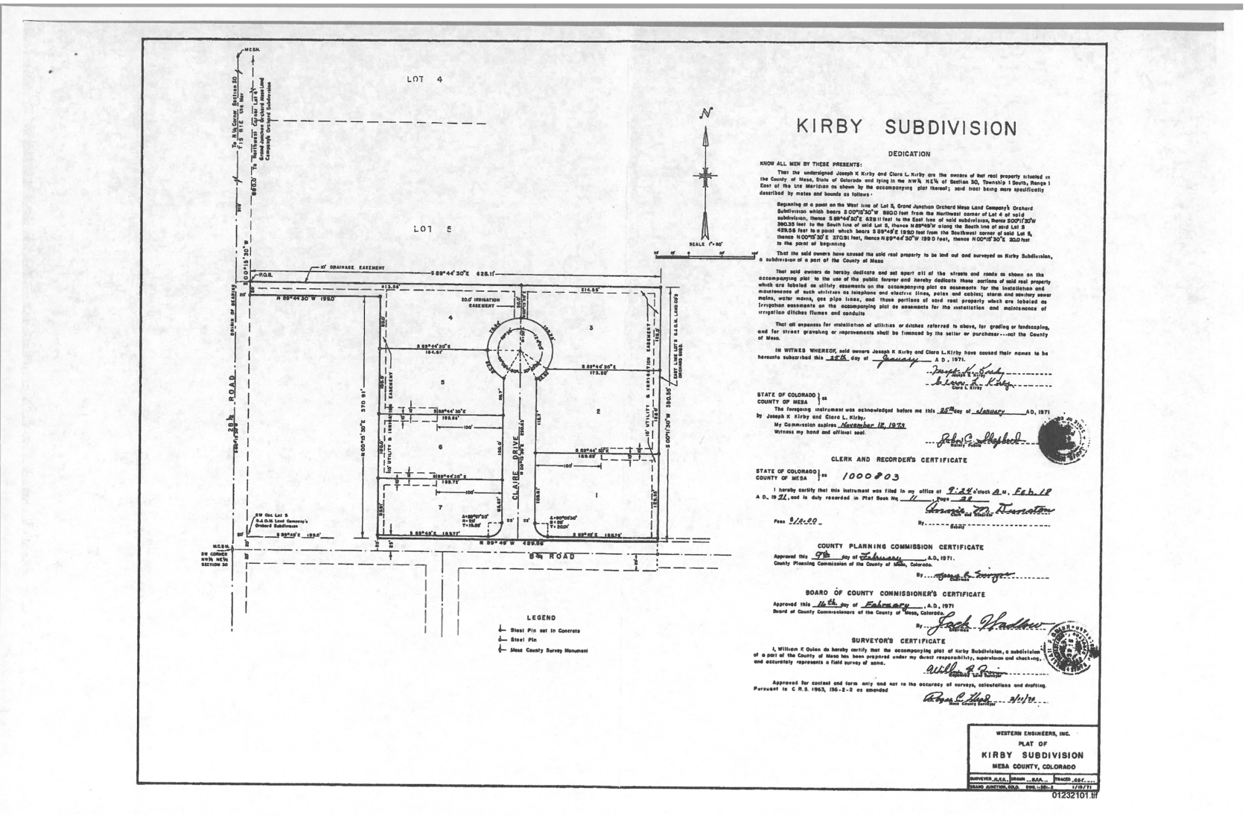**Exhibit “A”**