CITY OF GRAND JUNCTION, COLORADO

ORDINANCE NO. 4564

AN ORDINANCE AMENDING SECTION 21.07
OF THE GRAND JUNCTION MUNICIPAL CODE
TO ADD AN OVERLAY ZONE DISTRICT
FOR PROPERTY ABUTTING NORTH AVENUE
BETWEEN FIRST STREET ON THE WEST AND I-70 B ON THE EAST

Recitals:

On April 5, 2010 the Grand Junction City Council adopted the updated 2010 Zoning and Development Code, codified as Title 21 of the Grand Junction Municipal Code of Ordinances.

The Grand Junction City Council encourages updating of the Zoning and Development Code in order to maintain its effectiveness and responsiveness to the citizens’ best interests.

Section 21.07 provides special regulations in the Code to address zoning requirements that are specific to a defined boundary within the City limits.

The City Council finds that this amendment promotes the health, safety and welfare of the community, implements the North Avenue corridor plans, and contributes to the revitalization of the North Avenue corridor.

The City Council also finds that the amendment is consistent with reasonable business owner, property owner, the community and neighborhood expectations.

After public notice and a public hearing as required by the Charter and Ordinances of the City, the Grand Junction Planning Commission recommended approval of the proposed amendment for the following reasons:

1. The request is consistent with the goals and policies of the Comprehensive Plan.

2. The proposed amendment will help implement the vision, goals and policies of the Comprehensive Plan.

After public notice and a public hearing before the Grand Junction City Council, the City Council hereby finds and determines that an amendment to add use-specific standards for Racing Pigeons will implement the vision, goals and policies of the Comprehensive Plan and should be adopted.

NOW THEREFORE BE IT ORDAINED BY THE CITY COUNCIL OF THE CITY OF GRAND JUNCTION THAT:

A new Section 21.07.070 is added follows:

North Avenue Overlay Zone District

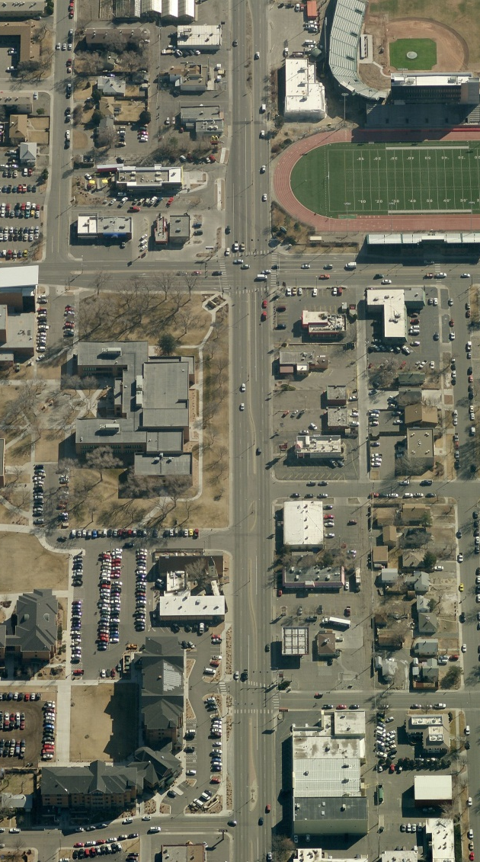
010 Background and Intent

Overlay Zoning

Overlay zoning creates a special zoning district over a base zone. An overlay adds to or changes the regulations, standards or requirements of the base zone in order to protect or guide development within a specific area or corridor to meet specific needs or objectives. While the base zone determines the permitted land uses, the overlay zone establishes design or other standards that meet the overlay’s purposes.

The overlay zone for North Avenue provides direction, vision and incentives for development in the corridor. The purpose of the overlay is to stimulate new development, redevelopment and business and other human activity along the corridor. The overlay supports and implements the Comprehensive Plan goal of making the City a more livable place. The overlay’s standards and guidelines are intended to stimulate commercial, pedestrian and other activity in the corridor.

- The Vision

The vision for the North Avenue corridor was established in the 2007 and 2011 North Avenue Corridor Plans (“the Plans”). The North Avenue Overlay Zone encourages development features considered critical to implementing the Plans by establishing guidelines, standards, development incentives and alternative approaches for development and redevelopment. The Plans envision buildings located near the street, front doors that are inviting and readily accessible, signage on the building rather than pole signs, more and safer pedestrian facilities, and an inviting streetscape, which will create an environment of vitality and livability.

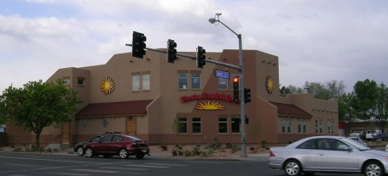
The “streetscape” is the area between the street curb and the building façade. The combination of the adjacent land use and the public space of the streetscape can create a dynamic and inviting space. Streetscape features that create a visually interesting corridor and a safer pedestrian and transit experience create a dynamic sense of place inviting activity. The overlay also includes development incentives to encourage design and development of an attractive streetscape.

- Revitalize North Avenue by establishing it as a “Complete Street”

Development is encouraged to be designed and built according to the Plans, which establish a “Complete Street” vision for North Avenue.

The North Avenue “Complete Street” concept includes:
- A multi-modal corridor designed for not only the vehicle, but also for the pedestrian, bicyclist and the transit user.
- Wide sidewalks detached from the roadway.
- Buildings located close to the street with pedestrian access to the building at the streetscape.
- Safe access to businesses from the street and sidewalks and parcel interconnectivity to minimize multiple access points to North Avenue.
- Safe and efficient transit stops.
- Adequate lighting creating a safer vehicle and pedestrian experience.
- Landscaping, street furniture and other hardscape features and amenities that enhance the pedestrian and motoring public’s experience, but still allow buildings to be near the street.
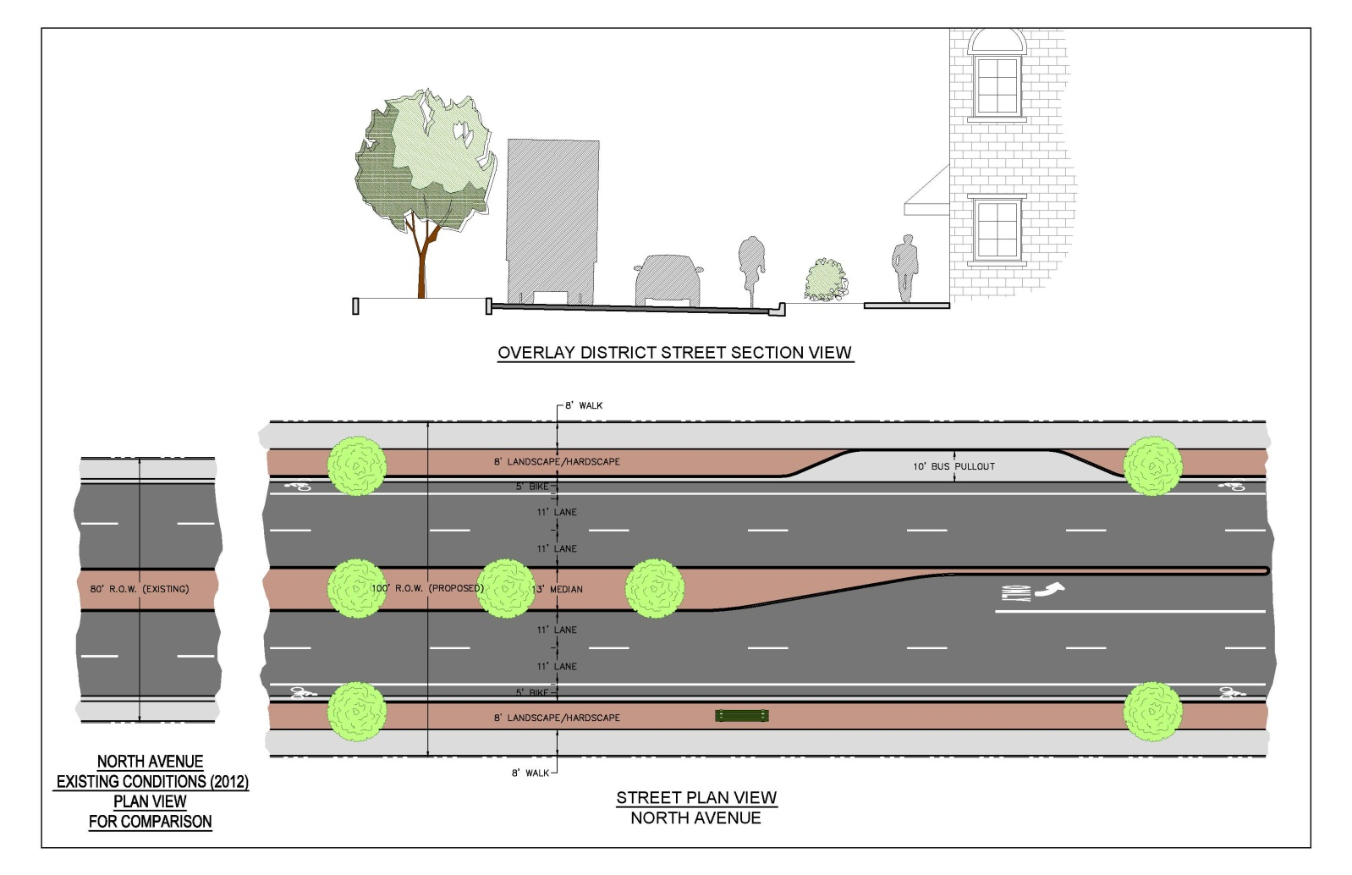
The diagram below establishes the right-of-way standards for the overlay district.
- Definitions
The following definitions apply to this Overlay:

Abutting means directly touching. For example, parcels across a public right-of-way from one another would not be abutting, but would be adjacent to one another.

Adjacent to something means lying within a 100-foot radius of it. For purposes of adjacency, public right-of-way, easements, canals, waste ditches and waterways are not included in the 100-foot calculation.

020 Options for Development within the District

The North Avenue Zoning Overlay establishes mandatory standards, “opt-in” standards, and a point-system for specific site upgrades. Any and all property development within the District must adhere to the mandatory standards, and in addition must choose among the following three options:
(1) follow all of the “opt-in” standards,
(2) develop according to the “base” zone standards, or
(3) upgrade a site using the point system.

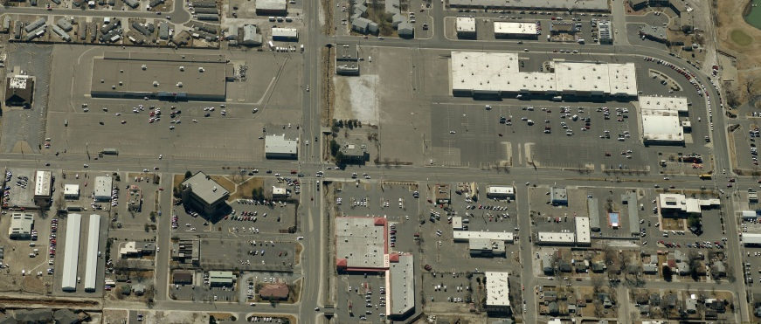
The mandatory standards of the Overlay Zone establish the right-of-way width and streetscape features for the corridor. The opt-in standards include incentives which relax some of the base-zone standards (landscaping requirements, for example) in exchange for meeting specified standards which will shape the desired character of the built environment. The point system allows a landowner to improve the site in specific ways which will help create the desired character of the built environment and provides framework for distribution of financial incentives that may become available. (The Overlay Zone does not establish those financial incentives, but merely establishes a point system for accessing such funds if and when they become available.)

030 Boundaries of the Overlay District

The North Avenue Overlay District applies to all properties abutting the North Avenue right-of-way from First Street on the west to I-70 Business Loop on the east.

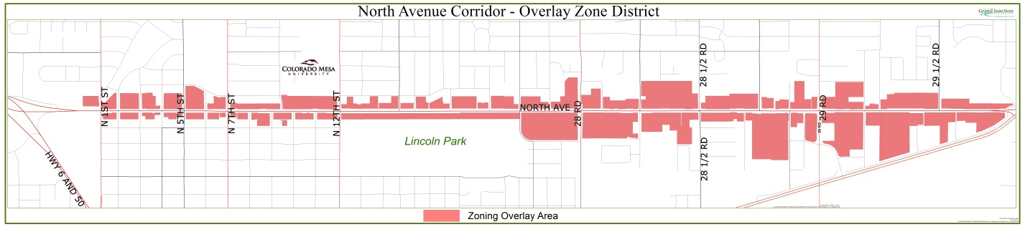

The North Avenue Overlay District applies to all properties abutting the North Avenue right-of-way from First Street on the west to I-70 Business Loop on the east.

040 Overlay Zone District Standards and Guidelines

- Applicability/conflicts. Where the standards or requirements of this Overlay Zone conflict with another overlay zone, area plan or the balance of the Zoning and Development Code, this Overlay shall control. Where another overlay zone or area plan gives the Director authority to waive, vary or diverge from a development standard, a requirement of a zone district or another land use regulation, that authority shall not apply to property within the boundaries of this Overlay District. The variance procedure and criteria set forth in Section 21.02.200 shall apply.

- Mandatory Standards

- Right-of-way Standards
All development in the Overlay District shall include dedication of sufficient right-of-way so that there are 50 feet of half right-of-way for North Avenue.

- Pedestrian / Sidewalk Standards
The North Avenue standard for public sidewalks is an 8 ft. detached sidewalk with an 8 ft. park strip separating the sidewalk from the street. In connection with any development in the Overlay District, the landowner shall dedicate the appropriate amount of land to meet those standards, and the landowner/developer shall construct the sidewalk and park strip areas to City specifications. Exception: The sidewalk and/or park strip widths may be adjusted if a building existing on the property that is not being demolished or substantially remodeled encumbers all or part of the area 16’ from the back of curb of North Avenue, provided that the adjustment is the minimum necessary to accommodate the building. Neither the sidewalk nor the park strip, however, can be eliminated altogether, and the sidewalk shall be the higher priority between the two.

The park strip is part of the streetscape and shall include pedestrian and transit amenities including landscaping and hardscape features. It shall include different features which distinguish it from the sidewalk; in other words, the park strip cannot be solid concrete pavement like the sidewalk.

Hardscape features and materials include, but are not limited to the following:
Benches Bike Racks Pedestrian lighting
Transit pullouts Transit shelters Trash cans
Planters Water features Art / sculptures
News Stands Mail boxes Banners, hanging baskets

Landowner/developer may select among these and other appropriate (as approved by the Director) hardscape features to install in the park strip. A minimum of two such features shall be installed in the park strip in front of the parcel being developed, improved or re-developed.

- Multipurpose easement
No multi-purpose easement is required along the North Avenue frontage. Utilities shall be located in the street right-of-way, to the rear of the property, in an alley, or in another appropriate location. If public utilities are located on private property, an easement shall be granted or dedicated for those utilities.

All other development standards of the Zoning and Development Code relating to right-of-way, sidewalk and park strip shall apply. Development of property within the District shall in all other respects not addressed in this Overlay meet the requirements of the balance of the Zoning and Development Code.

- Opt-In Standards

The Opt-In Section includes guidelines and standards. Guidelines are permissive recommendations for development; standards are mandatory requirements once the developer/landowner has opted in.

- Benefits/incentives. There are significant benefits to opting in to the standards of this section. Opting into all these standards entitle a landowner/developer to the following reductions to the base-zone and other Zoning and Development Code standards:

(i) Landscaping and Buffering:
Landscaping is required only in parking areas.
- No landscaping / screening buffer is required between adjacent properties.
- No street-frontage landscaping is required.
- Where all parking is located behind a building, no landscaping along access from North Avenue is required.
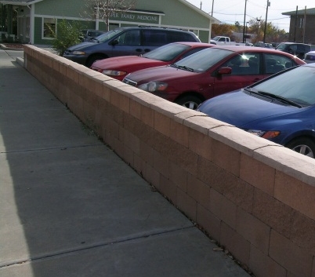
- No street trees are required in front of buildings that abut or are within 10 ft. of North Avenue right-of-way. If a parking area abuts the North Avenue right-of-way, street trees are required along the North Avenue street frontage of the parking area.
- A 30 inch tall decorative screen wall may be substituted for the required parking lot screening between the parking lot located at the right-of-way / property line and North Avenue. Shrub planting in front of the wall is not required for this option.
All other landscaping regulations of the Grand Junction Municipal Code shall apply.

Purpose: North Avenue is a major commercial district located within the City Center. Historically its development pattern has been both urban and suburban in scale. The Comprehensive Plan identifies high growth in the City Center area through 2035 as the community nearly doubles in population. The Plans likewise emphasize urban growth along the North Avenue corridor, including more building mass, hardscape areas, less landscaping, and more pedestrian activity.

(ii) Setbacks
The building setback is reduced to zero.
- Minimum building setbacks:
Front = 0 ft.
Side = 0 ft.
Rear = 0 ft.

Purpose: Reducing the setbacks to zero creates more buildable area and creates a more urban built environment. This standard also encourages better site design and compliments the streetscape by emphasizing a pedestrian experience.

(iii) Parking space credits (See below).

- Standards:

(i) Maximum Building Setback = 10 ft.
The maximum building setback of 10 feet applies to all building construction including additions with exceptions for public plazas, outdoor seating areas and other pedestrian spaces.

Purpose: A maximum building setback of 10 feet supports the streetscape vision for North Avenue. Buildings close to the street enhance the pedestrian experience and create visual interest along the corridor.

(ii) Drive thru lanes
Drive thru lanes shall not be installed between the North Avenue right-of-way and the building.

Purpose: This standard will reduce conflict between vehicles and pedestrians entering the building from the front and therefore enhance pedestrian activity and safety. In the first two examples pictured below, there are potential conflicts between motorists and pedestrians because a drive lane interferes with pedestrian access from North Avenue. The third picture (Taco Bell) shows a drive thru lane that does not interfere with the front door access into the restaurant reducing pedestrian/vehicle conflicts and making pedestrian access to the building safer.
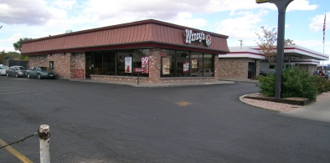
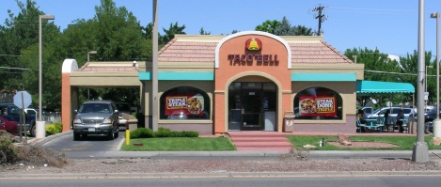
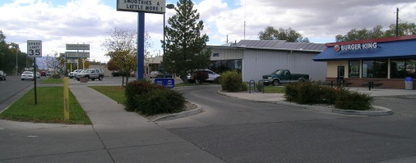

(iii) Parking
(A) Parking shall not be permitted between the building and the North Avenue right-of-way.

Purpose: The purpose of this standard is to reduce the amount of parking along the North Avenue frontage and to emphasize the buildings and pedestrian friendly streetscape.

(B) All development shall meet the parking requirements established for the use and the base zone with the following exception. Parking space credit shall be allowed under the following conditions:
- Providing shared parking between two abutting properties through a recorded, permanent shared parking easement.
- When on-street parking is available (for corner lot development only), two on-street spaces may count as one onsite parking space.

(iv) Awning Standards
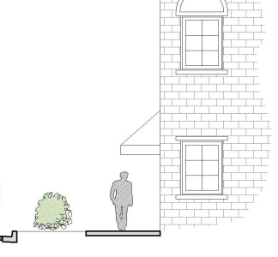
Awnings and other façade enhancements are encouraged. One or more awnings extending from the building may be erected. Awnings shall be at least 8 feet above the sidewalk and shall be at least 4 feet wide, along the building frontage on North Avenue, and shall not overhang into the right-of-way more than 6 ft. Awnings shall otherwise meet with the requirements of the Grand Junction Municipal Code and Colorado Department of Transportation (CDOT) regulations.

Purpose: Awnings provide visual interest to the corridor and enhance the pedestrian experience.

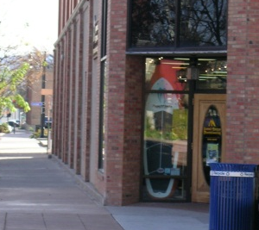
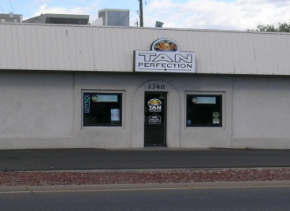
(v) Building Entry Standards
The main entrance to the building shall be on the North Avenue face of the building. Additional entrance(s) may be provided on the side and/or rear of the building to parking areas or other pedestrian facilities. A front door may be constructed anywhere along the front façade of the building including at the corner of the front façade as shown in the two examples pictured to the right.

Purpose: When an entrance is visible from the North Avenue corridor, it invites in the pedestrian and motorist alike. A front door also provides direct pedestrian access from the public sidewalk within the streetscape, supporting the revitalization of North Avenue as envisioned by the Plans.

(vi) Development of property within the District shall in all other respects not addressed in this Overlay meet the requirements of the balance of the Zoning and Development Code.

- Guidelines

Whenever possible North Avenue development/redevelopment should:
- Minimize the number of traffic conflict points into and out of a business.
- Create pedestrian, bike and transit friendly amenities.
- Better define and consolidate driveways into businesses and access between/among businesses to minimize vehicle access points onto North Avenue.
- Provide turn lanes where appropriate.
- Maximize the use of existing local streets and alleys for access to eliminate vehicle access points onto North Avenue.
- Include awnings or other visually interesting building features on the front of the building to provide visual interest and enhance the pedestrian experience.
- Include living landscaping within the parkstrip. The use of xeric landscape is encouraged.

Purpose: These guidelines promote pedestrian safety and efficient vehicle movement and provide visual interest along the corridor.

- Site Upgrade Point System

- This section is known and may be cited as the “Site Upgrade Point System for the North Avenue Overlay Zone District.” It establishes a rating system whereby points are awarded in the development review process when a developer/owner upgrades a site or structure to meet the standards established by the North Avenue Overlay Zone and/or to achieve the vision of the Plans. An owner may choose to develop under this section in lieu of the “opt-in” section of the Overlay District. Also, an owner who “opts in” can receive points for those aspects of the development that are listed in the “Improvement Table”.

- Purpose. The purpose of this Site Upgrade Point System is to encourage property owners along North Avenue to take steps that will bring their existing structures and sites more into alignment with the vision for the corridor as established by the Plans and by this Overlay.

- Use with nonconformities. When installing only one or more specific site upgrade(s) selected from table below, without making other site improvements, a landowner with a nonconforming use, site or structure is not required to bring the site or structure into conformance with the Code as prescribed in the “non-conformities” section of the Zoning and Development Code. However, if such landowner undertakes a site or structure remodel that includes improvements not listed in the table below, the non-conforming section of the Zoning and Development Code applies, or, if the developer/owner has opted in, the opt-in standards apply.

- Validity of points. Points may be awarded by the Director according to the table below. The points are assignable (subject to any expiration date or time established in the program), but may only be assigned one time. Points can also be shared by two or more landowners (for example, where adjacent owners agree to consolidate and eliminate access points and establish cross-access between or among parcels). If points are shared, the owners must agree in writing to the allocation of points between/among themselves.

- Improvement Table and Point Values. The Improvement Table below establishes the improvements to the right-of-way, streetscape and private property that are encouraged by the Plans and by this Overlay and the points that will accrue upon completion of said improvements. The Improvement Table may be amended by the City Council by resolution. Regardless of the point values in the Improvement Table, no points shall be awarded for improvements to private property or to right-of-way that are part of a capital improvement program or project of any governmental entity, including but not limited to the City, the County or the Colorado Department of Transportation.

Improvement Table
First Priorities | Points
Construction of detached sidewalk/parkstrip running the entire length of the property along North Avenue and meeting the overlay standards. Total points are determined by dividing proposed streetscape area sq ft by 1600 sq. ft. and multiplying by 30 pts.  Benefit: Aesthetics and Pedestrian Safety | 30
Right-of-way dedicated along North Avenue for entire frontage sufficient to allow 8 ft. detached sidewalk and 8 ft. park strip. Total points are determined by dividing the dedicated ROW area sq ft by 1000 sq. ft. and multiplying by 30 pts.  Benefit: Pedestrian Safety | 30
Elimination of a North Avenue street access point¹, including construction of curb and gutter and removing the driveway apron and must include dedication of all required North Avenue right-of-way.  Benefit: Pedestrian and Vehicle Safety | 20
Second Priorities | Points
Pole or free-standing sign removed and sign placed on building façade  Benefit: Aesthetic Value | 7
Addition of plaza, fountain or outdoor dining in front of building along North Avenue  Benefit: Pedestrian Access and Aesthetic Values | 7
Construction of an addition to building that meets maximum setback (10 or fewer feet from property line); shall include the addition of a front door facing North Avenue; and 50 ft. half right-of-way must be dedicated.  Benefit: Pedestrian and Aesthetic Values | 6
Elimination of parking along North Avenue frontage and placing all parking behind building(s)  Benefit: Pedestrian Safety and Aesthetic Values | 5
Pole sign removed and replaced with a monument sign  Benefit: Aesthetic Value | 5
Elimination of parking along North Avenue in front of the building(s) and all parking placed along the side and/or behind the building(s)  Benefit: Pedestrian Safety and Aesthetic Values | 3
Parking shared with adjacent properties²  Benefit: Aesthetic Value | 3
Permanent elimination of front yard display or storage³  Benefit: Aesthetic Value | 2
Two hardscape features installed in park strip (maximum for point system)  Benefit: Aesthetic Value | 2
One hardscape feature installed in park strip  Benefit: Aesthetic Value | 1
¹Can be accomplished by sharing access point with neighbor by a cross access easement (which must be reviewed and approved by the City Attorney), or by one property taking access from a lower order street.
²Must be established by recorded permanent easement appurtenant, not by shared parking agreement.
³Must be established by amended site plan, CUP or other land use approval.

- Incentive program. If and when funding becomes available, the Director shall develop a program and process for allocating funds to points under the Improvement Table.

- Appeals. Any person aggrieved by a decision of the Director regarding an award of points or incentive funds under this section may appeal that decision to the City Council within 30 days of the decision.

All other provisions of Section 21.07 shall remain in full force and effect.

INTRODUCED on first reading the 6th day of February, 2013 and ordered published in pamphlet form.

PASSED and ADOPTED on second reading the 20th day of February, 2013 and ordered published in pamphlet form.

ATTEST:

____________________________
President of the Council

____________________________
City Clerk

