**CITY OF GRAND JUNCTION, COLORADO**

**ORDINANCE NO. 4568**

**AN ORDINANCE AMENDING THE COMPREHENSIVE PLAN OF THE CITY OF GRAND JUNCTION TO AMEND THE GRAND VALLEY CIRCULATION PLAN FOR THE AREA LOCATED GENERALLY NORTH OF I-70 BUSINESS LOOP**

**BETWEEN 28 AND 28 1/4 ROADS**

Recitals:

A request for a Comprehensive Plan Amendment to amend the Grand Valley Circulation Plan has been submitted in accordance with the Zoning and Development Code. The applicant has requested that the area generally located north of the I-70 Business Loop between 28 and 28 1/4 Road, be amended as identified on Exhibit A to include Gunnison Avenue and a rerouted Grand Avenue as a Proposed Major Collector along with an Unclassified new street that will connect Gunnison Avenue with Grand Avenue to improve future capacity, connectivity and circulation.

In a public hearing, the City Council reviewed the request for the proposed Comprehensive Plan Amendment to amend the Grand Valley Circulation Plan and determined that it satisfied the criteria as set forth and established in Section 21.02.130 (c) (2) of the Zoning and Development Code and the proposed amendment is consistent with the purpose and intent of the Comprehensive Plan.

NOW, THEREFORE, BE IT RESOLVED BY THE CITY COUNCIL OF THE CITY OF GRAND JUNCTION THAT THE GRAND VALLEY CIRCULATION PLAN BE AMENDED AS IDENTIFIED ON EXHIBIT A.

**INTRODUCED** on first reading the 6th day of February, 2013, and ordered published in pamphlet form.

**ADOPTED** on second reading the 20th day of February, 2013, and ordered published in pamphlet form.

ATTEST:

_____________________________ ___________________________

City Clerk President of Council

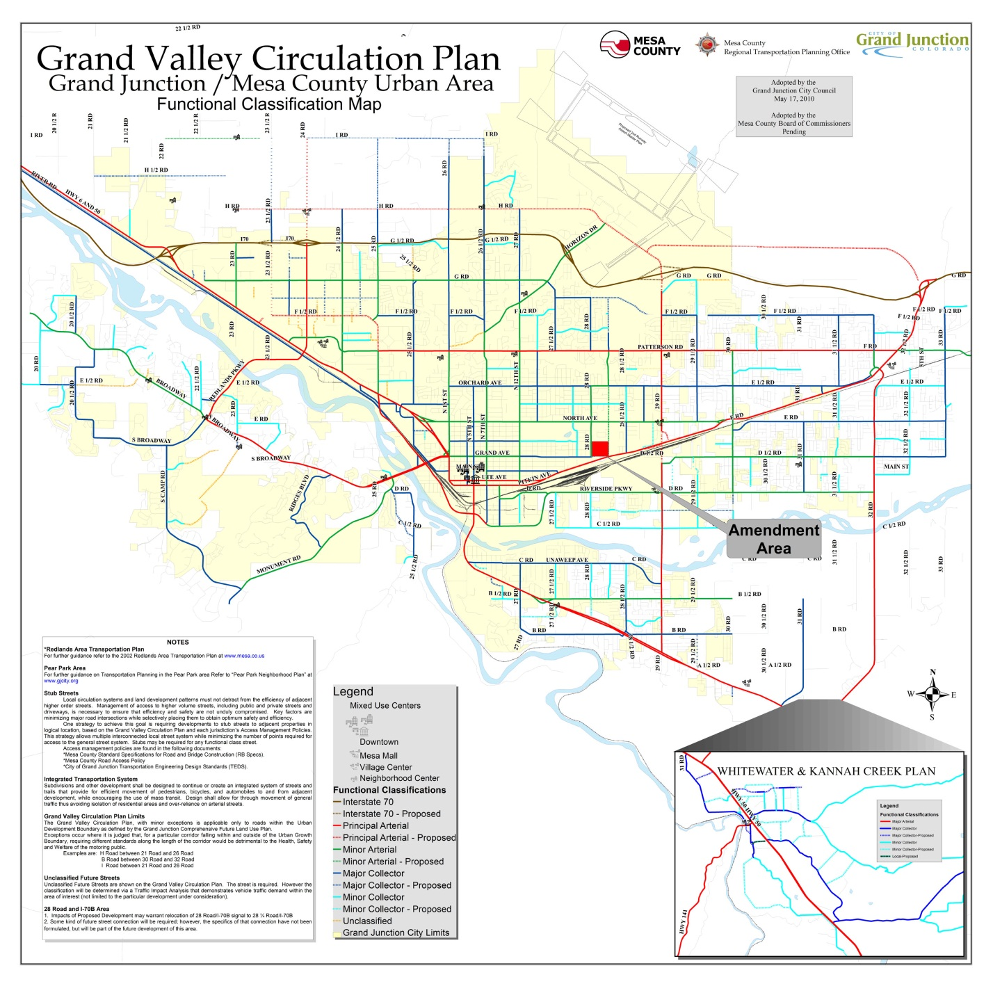

**Exhibit “A”**

