**CITY OF GRAND JUNCTION, COLORADO**

**RESOLUTION NO. 15-13**

**A RESOLUTION ADOPTING AN AMENDED REDEVELOPMENT BOUNDARY MAP AND CREATING A FORMULA REDUCING THE TCP REQUIREMENTS WITHIN THE REDEVELOPMENT AREA**

**RECITALS:**

In September, 2004 the City Council reviewed and approved the Infill and Redevelopment Implementation Program by adopting policies outlined in Resolution No. 87-04. The Resolution described the framework of the infill and redevelopment program, defined terms and established infill and redevelopment areas.

The implementation of the program was adopted to encourage development of infill parcels and redevelopment of underutilized land within certain areas of the City of Grand Junction for several beneficial reasons. Such development:

* Makes more efficient use of existing infrastructure including streets, water and sewer lines and other public facilities and services;
* Provides opportunities to reduce commuting distance/automobile dependency;
* May help to provide affordable housing within the City; and
* Reduces the demand for and impact from “end of the road” suburban sprawl.

By adopting this resolution, the City Council reaffirms the original policies and guidelines set forth in the Infill and Redevelopment Implementation Program. However, City Council finds that there is a need to amend the Redevelopment Area and add additional clarification that would reduce the Transportation Capacity Payment for new development within the Redevelopment Area.

For the reasons stated in the foregoing recitals, the City Council of the City of Grand Junction does hereby amend the Infill and Redevelopment Implementation Program by the attached Redevelopment Area Map and Transportation Capacity Payment calculation for new development within in the Redevelopment Area.

**BE IT RESOLVED BY THE CITY COUNCIL OF THE CITY OF GRAND JUNCTION, COLORADO:**

The Infill and Redevelopment Implementation Program is hereby amended as follows:

1. The attached Exhibit A is adopted as the new Redevelopment Area Map.
2. The attached Exhibit B is adopted as the calculation to reduce Transportation Capacity Payments for new development within the Redevelopment Area.

**ADOPTED AND APPROVED THIS 6th** day of March, 2013.

/s/: Bill Pitts

President of the Council

ATTEST:

/s/: Stephanie Tuin

City Clerk

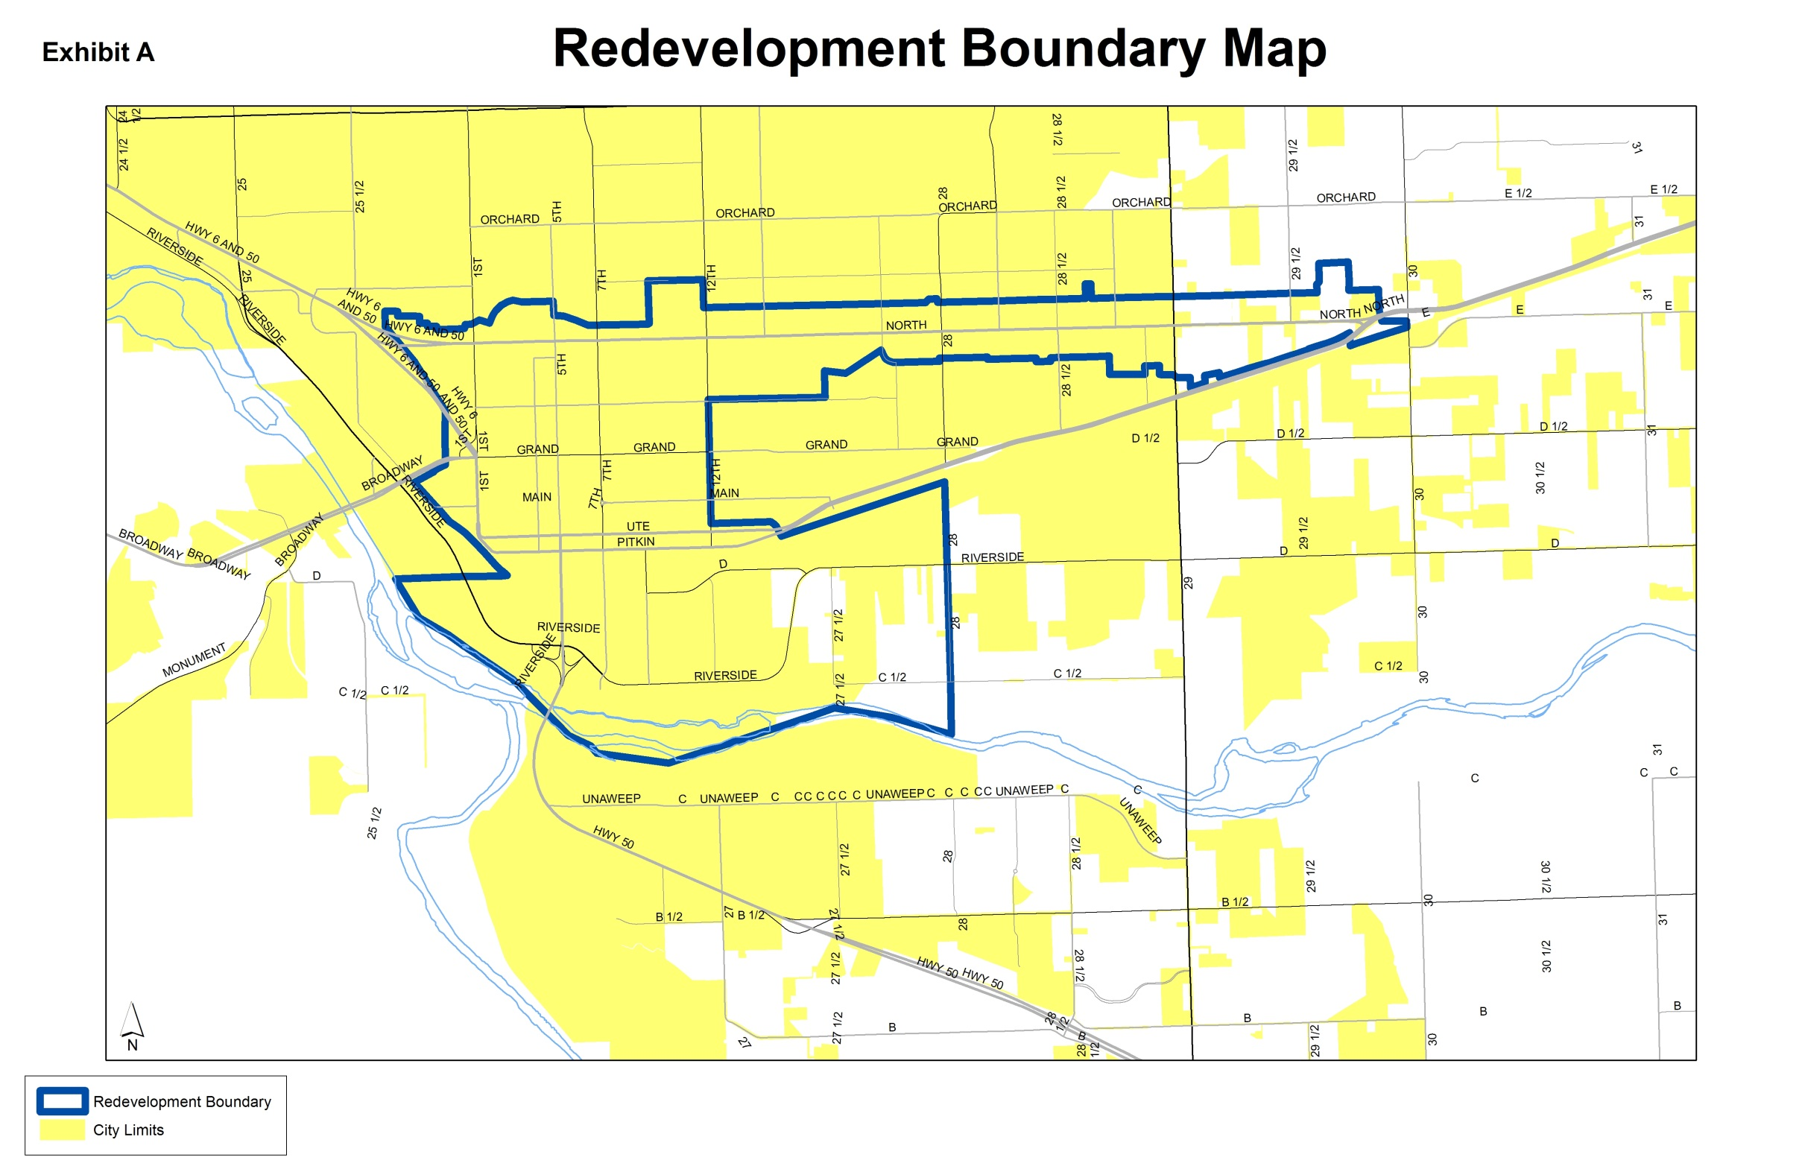

**Exhibit B**

Within the Redevelopment Area any new development would be assessed a TCP using the following calculation:

rTCP = (tTCP/n)*.5

rTCP – Reduced Transportation Capacity Payment

tTCP – Total Transportation Capacity Payment calculated for all uses within the building

n – The number of floors