RESOLUTION NO. 16-13
A RESOLUTION AUTHORIZING THE CITY MANAGER TO SIGN THE AGREEMENT BY AND BETWEEN STRIVE/MDS, THE WESTERN COLORADO BOTANICAL SOCIETY AND THE CITY OF GRAND JUNCTION CONCERNING THE BOTANICAL GARDENS AND RATIFYING ACTIONS HERETOFORE TAKEN IN CONNECTION THEREWITH
RECITALS:
The City of Grand Junction (“City”), the Western Colorado Botanical Society (“Society”) and Mesa Developmental Services also known as Strive (“MDS” or “Strive”) are parties to a proposed agreement concerning certain real property located west of 8th Street and south of Struthers Avenue, Grand Junction, Colorado herein referred to and known as the (“Property” or the “Botanical Gardens Property.”)
The City leased the Property to the Society. During the term of the lease the Society established on the Property a community botanical gardens program and improved the Property with outdoor gardens, greenhouses, a children’s castle, a butterfly pavilion and other related facilities and amenities, which are intended for public use and enjoyment as well as related educational, cultural, horticultural, recreational and fund-raising purposes. Together those improvements are now known as the Botanical Gardens.
Despite the dedicated support of many Society members and other committed volunteers and patrons, in recent years the Society encountered a number of challenges that jeopardized the continued operation and success of the Botanical Gardens. In order to manage the Botanical Gardens the Society turned to MDS, a nonprofit organization providing community-based services and support for persons with developmental disabilities, to provide the necessary organizational support, assistance and resources to restore and rejuvenate the Gardens as a viable community asset.
Since December 2011 MDS has, with the City’s full knowledge and consent and in consultation with the Society, undertaken management and operation of the Botanical Gardens Property and its successes in doing so are recognized by all of the parties.
In order to continue the success that MDS has had with its operations of the Botanical Gardens Property the parties have jointly reviewed their relationship and have determined that the parties’ respective interests, including the Society’s goals and vision regarding the Botanical Gardens, MDS’ desire for a sustainable venture providing employment, volunteer and enrichment opportunities for the persons with disabilities it serves and the City’s master plan for the development of the area can best be achieved by terminating the lease and restructuring the parties’ rights and obligations regarding the Property and operation and development of the Botanical Gardens in accordance with the terms and conditions established by and found mutually agreeable to the parties in the Agreement.
NOW, THEREFORE, in consideration of the above recitals and the other terms and conditions of the Agreement, the City Council does hereby resolve that:
- The City Council hereby authorizes the City Manager to sign the Agreement finding that the Agreement is necessary and proper.

- All actions heretofore taken by the officers, employees and agents of the City relating to the Agreement which are consistent with and/or arise out of or under the Agreement are hereby ratified, approved and confirmed.

- That the officers, employees and agents of the City are hereby authorized and directed to take all actions necessary or appropriate to effectuate the provisions of this Resolution and the attached Agreement, including, without limitation, the execution and delivery of such certificates and documents as may be necessary or desirable.

FURTHERMORE, be it resolved that the City Council does offer its sincere thanks and gratitude to the Western Colorado Botanical Society for its past vision and stewardship and to MDS/Strive for its current and future commitment to the Botanical Gardens and those who tend, visit and enjoy the same.

PASSED and ADOPTED this 6th day of March, 2013.

/s/: Bill Pitts
President of the Council
ATTEST:

/s/: Stephanie Tuin
City Clerk

Agreement
Between the City of Grand Junction,
The Western Colorado Botanical Society
And
Strive Formerly Mesa Developmental Services

THIS Agreement is made and entered into as of March _____, 2013, by and between the City of Grand Junction (“City”), a Colorado home rule municipality, The Western Colorado Botanical Society (“Society”), a Colorado nonprofit corporation, and Mesa Developmental Services (“MDS”), a Colorado nonprofit corporation. The City, Society and MDS shall be referred to collectively herein as the “parties.”

RECITALS

WHEREAS, the City owns certain real property located west of 8th Street and south of Struthers Avenue, Grand Junction, Colorado herein referred to as the “Property”; and

WHEREAS, the City leased the Property to the Society for an initial term of twenty (20) years pursuant to a lease dated June 24, 1994 (the “Lease”); and

WHEREAS, during the term of the Lease the Society has established on the Property a community botanical gardens program, and in furtherance of the program has improved the Property with outdoor gardens, greenhouses, a children’s castle, a butterfly pavilion, and other related facilities and amenities, which are intended for public use and enjoyment as well as related educational, cultural, horticultural, recreational and fund-raising purposes. Such program and its related improvements, amenities, operations and activities on the Property shall be referred to collectively herein as the “Gardens”; and

Whereas, despite the dedicated support of many Society members and other committed volunteers and patrons, in recent years the Society encountered a number of challenges that jeopardized the continued operation and success of the Gardens, and ultimately it turned to MDS, a nonprofit organization providing community-based services and supports for persons with developmental disabilities, to provide the necessary organizational support, assistance and resources to restore and rejuvenate the Gardens as a viable community asset; and

WHEREAS, since December 2011 MDS has, with the City’s full knowledge and consent and in consultation with the Society, undertaken management and operation of the Gardens, and its success in doing so is recognized by all of the parties; and

WHEREAS, the parties have jointly reviewed their relationship with respect to the Property and the Gardens, and have determined that the parties’ respective interests, including the Society’s goals and vision regarding the Gardens, MDS’ desire for a sustainable venture providing employment, volunteer and enrichment opportunities for the persons with disabilities it serves, and the City’s master plan for the development of the area, including the Property, can best be achieved by terminating the Lease and restructuring the parties’ rights and obligations regarding the Property and operation and development of the Gardens in accordance with the terms and conditions set forth herein;

NOW, THEREFORE, in consideration of the above recitals and the other terms and conditions of this Agreement, the parties agree as follows:

1. Termination of Lease. The City and Society hereby terminate the Lease, and no party to the Lease shall have any further right or obligation thereunder as of the date of this Agreement. This Agreement shall replace and supercede the Lease in all respects.

a. The Society waives, relinquishes and gives up any right, title or interest it may have in the Property and any improvements thereto, including any right to remove improvements constructed on or permanently affixed to the Property pursuant to Paragraph 18 of the Lease. Subject to subparagraphs b. and e. of this Paragraph, the parties agree that ownership of any and all presently existing intangible assets or intellectual property rights in connection with the Gardens, such as copyrights, trade marks or trade names, are or shall be retained and owned by the Society. The parties agree to execute any documents or instruments that any party deems reasonably necessary to effectuate this provision.

b. In consideration of this Agreement, the Society agrees to assign and convey all of its right, title and interest in any Society-owned tangible personal property now located on the Property or used in the operation of the Gardens, including, but not limited to, furniture, removable trade fixtures, tools, mowers and other equipment and related implements or items, to MDS in “as is” condition, free and clear of any liens or encumbrances. Society agrees to execute a bill of sale or other instrument MDS deems necessary to fully effectuate this provision.

c. City, for itself, its officers, governing council, agents, legal representatives, successors and assigns, and for and on behalf of any person or entity who may assert any claim derived from any claim which has been or could be asserted by it, hereby releases and forever discharges MDS and Society, their respective officers, directors, employees, agents, successors and assigns, or any of them from any and all claims, damages, actions, suits or demands of any kind or nature whatsoever, whether known, unknown, foreseen, unforeseen, foreseeable or unforeseeable, legal or equitable, accrued or unaccrued, arising from or in any way related to the Lease or its formation, performance or termination, or regarding the use, operation or condition of the Property or the Gardens prior to the date hereof.

d. Society, for itself, its officers, directors, agents, legal representatives, successors and assigns, and for and on behalf of any person or entity who may assert any claim derived from any claim which has been or could be asserted by it, hereby releases and forever discharges MDS and City, their respective governing boards, officers, directors, employees, agents, successors and assigns, or any of them from any and all claims, damages, actions, suits or demands of any kind or nature whatsoever, whether known, unknown, foreseen, unforeseen, foreseeable or unforeseeable, legal or equitable, accrued or unaccrued, arising from or in any way related to the Lease or its formation, performance or termination, or regarding the use, operation or condition of the Property or the Gardens prior to the date hereof.

e. Society, for itself, its officers, directors, agents, legal representatives, successors and assigns, and for and on behalf of any person or entity who may assert any claim derived from any claim which has been or could be asserted by it, covenants and agrees not to assert any right, claim or demand, or file, commence or prosecute any claim or cause of action or take any other action to prevent, challenge, impair, impede, or interfere with the rights and obligations of the City and MDS with regard to the operation of the Gardens or use of the Property as set forth in this Agreement; provided, however, that neither the City nor MDS shall use, in connection with the Gardens or their activities or programs associated therewith, the names or marks listed on the attached Exhibit C without the Society’s prior written consent.

2. Grant of Licenses.

a. Subject to the terms and conditions of this Agreement and without rent or other charge, the City hereby grants and conveys to MDS an exclusive license to conduct and manage the day-to-day business and horticultural operations of the Gardens as the same are depicted on Exhibit A attached hereto (“Licensed Area”) during the term of this Agreement. Such exclusive license shall authorize MDS to:

(1) charge admission fees, pass fees, use or activity fees for entrance to or use of the Gardens and/or the Licensed Area, prepare and/or sell concessions or concession products, install vending machines, and offer for retail sale gifts, toys, clothing items, souvenirs, books, seeds, bulbs or other botanical, horticultural or gardening tools, products or inventory.

(2) keep and retain any and all fees, charges, sale proceeds and other funds or revenue derived from or generated by its operations.

(3) locate, plant and cultivate annuals, perennials and other plant materials or botanical exhibits on the grounds of the Licensed Area in accordance with a plan developed in cooperation with the City in accordance with Paragraph 4.d. below. That plan shall be Exhibit B to this agreement and is incorporated by this reference as if fully set forth.

(4) conduct fund-raising or other private events and activities on the Licensed Area and retain the proceeds thereof.

(5) manage, control and provide general supervision over operation of the Gardens and Licensed Area, including, but not limited to, setting of reasonable hours of operation, recruiting and supervising volunteers, scheduling and approval of events and activities, controlling and regulating public and adopting and enforcing reasonable rules and regulations for patrons and other visitors to the Gardens and Licensed Area.

(6) Perform all services that are necessary and proper for the operation and management of the Gardens and Licensed Area and report to Owner promptly any conditions concerning the Property that, in the opinion of MDS, require the City’s attention.

b. Subject to the terms and conditions of this Agreement, the City further grants and conveys to MDS a nonexclusive license authorizing the latter to occupy and use the Gardens and Licensed Area and the improvements and facilities thereon for the purposes set forth in Paragraphs 2 a. and 3 d. herein for the term of this Agreement.

c. The licenses granted by this Agreement shall not be revocable except upon termination of this Agreement as provided below, but shall not be construed to grant or convey to MDS any other property right or possessory interest. The Property and all present and future improvements thereto shall at all times remain the property of the City.

3. MDS’ Obligations. MDS shall:

a. supervise, monitor and control all activities authorized or permitted by it with regard to the safety of employees, volunteers and members of the general public, and shall establish and enforce reasonable rules and regulations regarding use or access to the Gardens and Licensed Area by the public.

b. refrain from constructing permanent improvements, erect obstructions or barriers (except of a temporary nature) or substantially alter the existing improvements or physical contours of the Property without the City’s prior written consent.

c. keep the Gardens and Licensed Area free of debris, collect and empty trash, and maintain restrooms in a clean and sanitary condition.

d. continue to operate and manage the Gardens and Licensed Area as a public amenity and attraction, and to use the same for a community botanical gardens program and related educational, cultural, horticultural, recreational and fund-raising purposes, and such other purposes as the City may approve in writing. Such operation and management shall be provided without cost or charge to the City. MDS may develop and implement programming at the Gardens that will maximize the benefits and opportunities for the persons with disabilities it serves, so long as such programs do not substantially conflict or interfere with such use and purposes.

e. document its revenues and expenses in connection with its operation of the Gardens. MDS shall make its financial and accounting records related to operation of the Gardens available for inspection and audit by the City within five (5) business days after notice by City to MDS requesting such inspection or audit.

f. pay for all utilities and other operational expenses of the Gardens except for trash service, irrigation and potable water, repairs and maintenance that the City is obligated to provide or perform as set forth in Paragraph 4 below. “Operational expenses,” as used in this paragraph, shall include the cost of food, concession and food products, beverages or other goods or products sold or offered for sale in the course of Gardens business. MDS may separately contract with the City, by and through Two Rivers Convention Center to supply beverages and/or other concession foods/food products, and the cost of the same to MDS shall be the City’s actual cost.

g. procure and maintain commercial general liability insurance covering all MDS’ operations in connection with the Gardens including operations, property damage, and personal injury with a combined single limit of not less than $1,000,000.00 per occurrence / $2,000,000.00 general aggregate. The City shall be an additional named insured on MDS’ insurance. MDS shall provide the City with an ACORD form evidencing the insurance in the form and amount required by the City. MDS’ insurance shall not be cancelled without thirty (30) days’ advance written notice to the City.

h. submit to the City, upon request, a schedule setting forth its then-current fees and charges for admission, concessions and other items offered for sale to the public in connection with the Gardens.

i. emphasize service to patrons of and visitors to the Gardens, and shall establish a policy requiring patrons to be greeted and served upon their admission to the Gardens, and to be thanked for their patronage upon their exit from the Gardens.

j. provide full and part-time staff sufficient to conduct the operations of the Gardens; however, the City understands and agrees that MDS may employ or otherwise assign persons with disabilities receiving services from MDS to perform any operational position or function at the Gardens, provided that such position is within such person’s skills and abilities, with or without reasonable accommodation, and such person is adequately supervised. MDS agrees to perform a reasonable background inquiry and screening with respect to any person who is assigned to work at the Gardens on a volunteer basis. Upon the City’s request, MDS shall remove and or replace any volunteer(s) the City deems unacceptable. The City agrees that it will consult with MDS about its needs/expectations for volunteers and that it will not unlawfully, arbitrarily or unreasonably request removal of any MDS volunteer.

k. order, stock and staff concession facilities in accordance with Mesa County Health Department and any other applicable local and/or state laws, rules and regulations, if it offers food or beverage concessions on the Licensed Area.

l. refrain from serving alcoholic beverages or allowing such beverages to be served on the Property except in accordance with a duly issued Special Event Permit as provided by Colorado law.

m. provide and perform all mowing and trimming, fertilization and weed abatement for the Gardens, and shall provide its own personnel, equipment and other resources as necessary for such purposes at MDS’ expense.

4. City’s Obligations. The City shall—

a. provide, at its sole expense, maintenance and repairs (including replacement when needed) of the improvements on the Property to the standard applied to the City’s other parks and recreational facilities, including but not limited to mechanical equipment, roofing, parking areas, sidewalks, lighting, security systems, plumbing, electrical systems, heating and air conditioning systems. Maintenance, repairs and upkeep shall be scheduled, insofar as practicable, so as not to unreasonably interfere with MDS’ operation of the Gardens; however, the City may impose reasonable temporary use limitations in order to protect Gardens facilities from waste or damage.

b. provide potable water service, trash removal and adequate irrigation water for the Gardens as presently located on the Property, and shall provide its own personnel, equipment and other resources as necessary for such purposes at City’s expense.

c. provide, at its sole expense, standard fire, casualty and extended coverage insurance covering the buildings and improvements in amounts reasonably acceptable to MDS. If the buildings situated on the Property should be damaged by fire, tornado or other casualty, and the City does not proceed with reasonable diligence to rebuild and repair such buildings to substantially the condition in which they existed prior to such damage, MDS may terminate this Agreement by the delivery of written notice of termination to City.

d. work cooperatively with MDS in connection with the latter’s operation of the Gardens and to design special interest garden areas and other improvements, and shall allow MDS to exercise the rights and privileges granted to it by this Agreement without unreasonable interference.

e. work closely with MDS to develop and/or revise the master plan for Las Colonias Park (“Park”) so that the Gardens are an accessible feature and attraction of the Park when it is developed. The City shall, if possible, include in the master plan options for new restroom facilities near the Gardens for public use. In the event the City completes construction of such facilities, MDS may limit the existing restrooms at the Gardens to Garden patron use only.

5. Society’s Obligations. During the term of this Agreement, Society agrees to consult with and offer technical assistance as reasonably requested by MDS and the City regarding the operation, maintenance, planning and future development of the Gardens. To the extent practicable, the Society agrees to work cooperatively with MDS and the City to sponsor, promote and advance fundraising and other community efforts in support of the Gardens.

6. Marketing. The parties shall collaborate and consult regarding marketing, advertising and promotion of the Gardens to the public as a public amenity and attraction, and in connection therewith MDS may enter into separate agreements with Society and/or City regarding such matters, including agreements regarding use and/or ownership of trade names, trade marks and other proprietary or copyrighted material associated with the Gardens or Gardens-related activities and programs; however, nothing herein shall obligate MDS or Society to disclose or share donor lists or other similar information of any kind containing names, addresses or other identifying information concerning their respective donors or contributors.

7. Capital Improvements. MDS shall neither direct nor require the City to perform any physical alterations to the facilities at the Gardens; instead, MDS and the City shall cooperatively plan for any capital improvements. In the event of a dispute, the City shall have and maintain final authority over all capital improvement projects affecting or involving the Property, the Licensed Area and/or the Gardens. Capital investment/improvement decisions regarding the Gardens shall be made by the City Park and Recreation Director as part of the Department’s annual budget, and shall be subject to the annual budgeting process of the City. As part of that budget review, the City and MDS shall meet and confer and develop both capital and operating plans for the succeeding year as provided in Paragraph 9 below. MDS, may with the City’s approval, make capital investments/improvements to the Gardens facilities at its own expense, but any improvements to the Property shall be owned by City.

8. Term and Termination. This Agreement may be terminated at any time by mutual agreement of MDS and the City, and may be terminated by either MDS or the City by giving sixty (60) days’ advance written notice to the other parties; however, no notice of termination by the City shall be valid or effective unless, within thirty (30) days before the date such notice is given, the City has provided the other parties an opportunity to address the City’s governing council regarding the proposed termination at a regular or special meeting of such council. Unless terminated as provided in this Paragraph, this Agreement will continue from year to year.

In the event of termination, MDS shall be liable for all expenses incurred in connection with the operation of the Gardens prior to the date of termination, and shall be entitled to receive and collect all revenues and accounts receivable generated by or attributable to its operation of the Gardens prior to the date of termination. At the termination of this Agreement, the City shall have ownership of all alterations, additions and improvements to the Property made by MDS, if any. All shelving, bins, equipment, furniture, machinery and other personal property or fixtures installed or used by MDS in the operation of the Gardens may be removed by MDS at the termination of this Agreement if MDS so elects, and shall be removed if required by City. All such removals and restoration shall be accomplished in a good workmanlike manner so as not to damage the primary structure or structural qualities of the buildings and other improvements situated on the Property. The parties’ obligations as specified in this paragraph and in the subparagraphs of Paragraphs 1 and 10 of this Agreement shall survive termination.

9. Conference. The City and MDS agree to meet at least once on before October 31 of each year while this Agreement remains in effect to address and resolve any issues or concerns by either party regarding operation of the Gardens or the use, development or maintenance of the Property, including, but not limited to, any proposed amendments or clarifications of this Agreement.

10. Indemnification.

a. To the extent permitted by applicable law, MDS and the City shall each defend, indemnify and hold harmless the other from and against any and all third party actions, claims, suits, liabilities and losses, including all costs, attorneys’ fees, expenses and liabilities incurred in the defense of any such third party claim or action or proceeding (collectively “Claims”) arising from or related to the negligent or intentional acts or omissions of the indemnifying party or its contractors, subcontractors, independent contractors, suppliers, volunteers, ofﬁcers, agents, employees, elected officials or servants in connection with their respective activities and programs upon the Property or use or operation of the Gardens under this Agreement. A party's obligation hereunder shall not be limited by the provisions of any workers’ compensation act or similar statute.

b. To the extent permitted by applicable law, each of the parties shall defend, indemnify and hold harmless the others from and against any and all Claims suffered or incurred on account of any breach by such party, or any of its contractors, subcontractors, independent contractors, suppliers, officers, agents, employees, elected officials or servants of any covenant, agreement, term or condition set forth in this Agreement.

c. Nothing contained herein shall limit the City’s protections under and by virtue of the Colorado Governmental Immunity Act, § 24-10-101, et. seq., C.R.S., or either parties’ other rights, protections, immunities, defenses or limitations on liability afforded under law or principles of equity.

11. Nature of relationship. The parties are independent contracting entities. The business operations of MDS shall not be combined in any way with the operations of the City, but instead shall be maintained separately and distinctly. Neither the Society nor MDS shall be or represent itself to be considered an agent, affiliate, partner or joint venturer of or with the City for any purpose, and neither MDS nor its volunteers, clients or employees shall not be entitled to any of the rights or benefits the City provides for the City's employees.

12. Notice. Any notice required to be given under this Agreement shall be in writing and shall be, and at the option of the party giving notice, (i) personally delivered, (ii) transmitted by certified or registered mail, return receipt requested, postage prepaid, or (iii) or sent by FedEx or other recognizable overnight courier, to the parties at their respective addresses set forth below. Each of the parties shall give notice of any change of address to the other parties by notice pursuant to this Paragraph.

If to the City: City of Grand Junction
250 North 5th Street
Grand Junction, CO 81501
Attn: Parks and Recreation Director

With a copy to the City Attorney
at the same address

If to MDS: Mesa Developmental Services
950 Grand Avenue
Grand Junction, CO 81501
Attn: Chief Executive Officer

If to Society: Western Colorado Botanical Society
621 Struthers Avenue
Grand Junction, CO 81501
Attn: President

13. Miscellaneous.
a. The terms, provisions and covenants and conditions contained in this lease shall apply to, inure to the benefit of, and be binding upon the parties hereto and upon their respective heirs, legal representatives, successors and permitted assignees, except as otherwise herein expressly provided.

b. This Agreement constitutes the entire agreement of the parties, and there are no representations, inducements or other provisions other than those expressed herein. All changes, additions or deletions hereto must be in writing and signed by all parties.

c. This Agreement shall be governed by and construed in accordance with the laws of the State of Colorado. Venue for all actions connected herewith shall be in Mesa County, State of Colorado.

[signature page follows]
City: CITY OF GRAND JUNCTION

Dated: ___________________ By _________________________________
Rich Englehart
Title: City Manager

MDS: MESA DEVELOPMENTAL SERVICES

Dated: ___________________ By _________________________________
Jeff Nichols
Title: Chief Executive Officer

SOCIETY: WESTERN COLORADO BOTANICAL SOCIETY

Dated: ___________________ By _________________________________
John Schler
Title: President

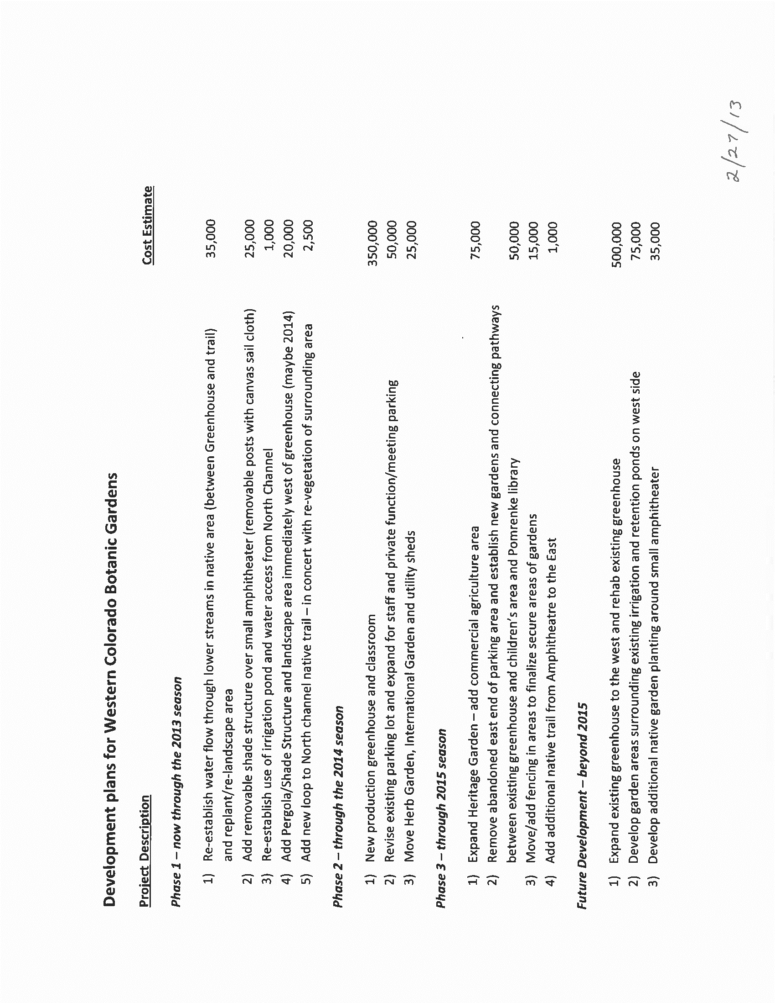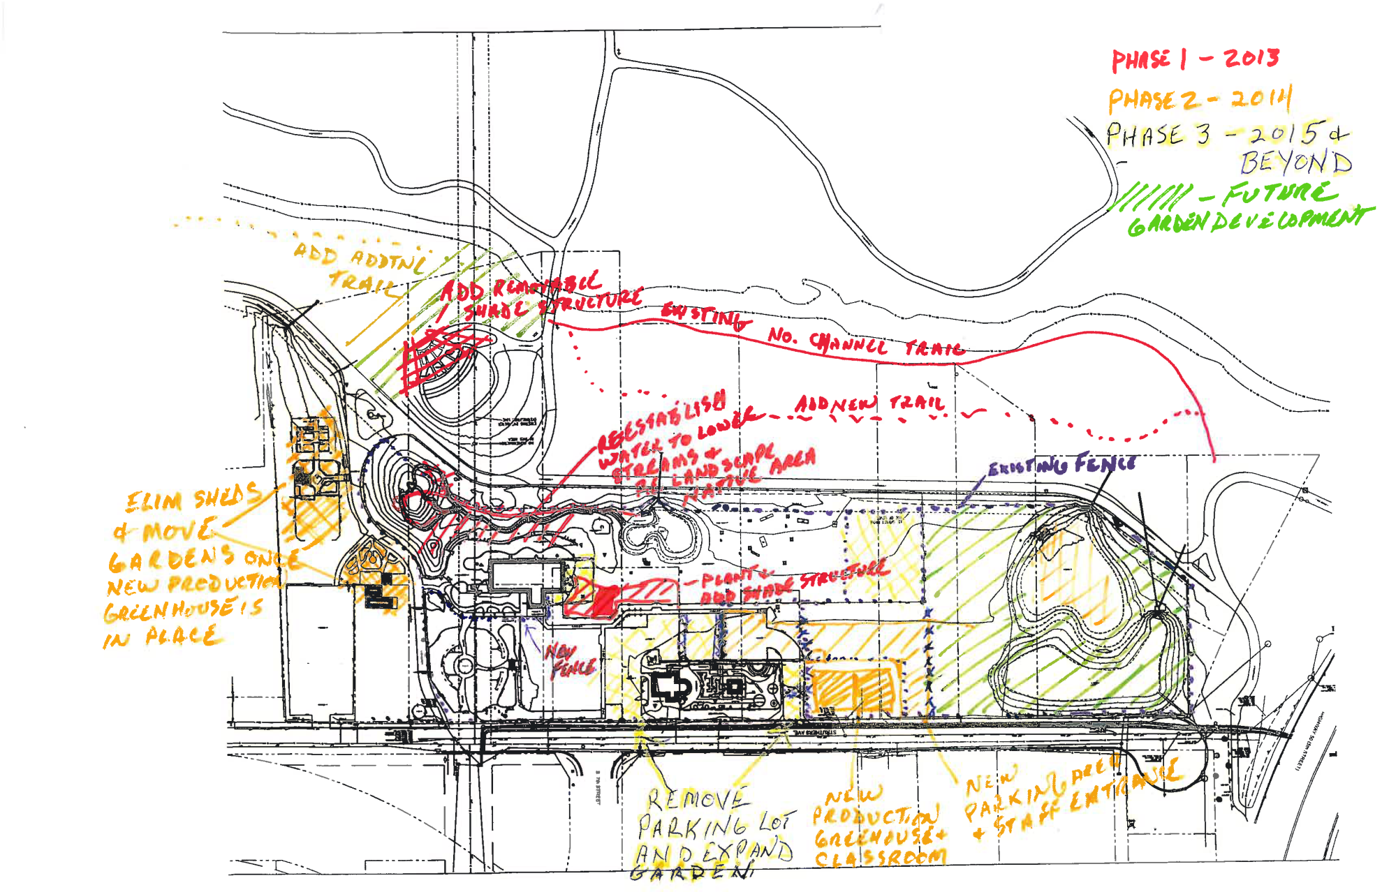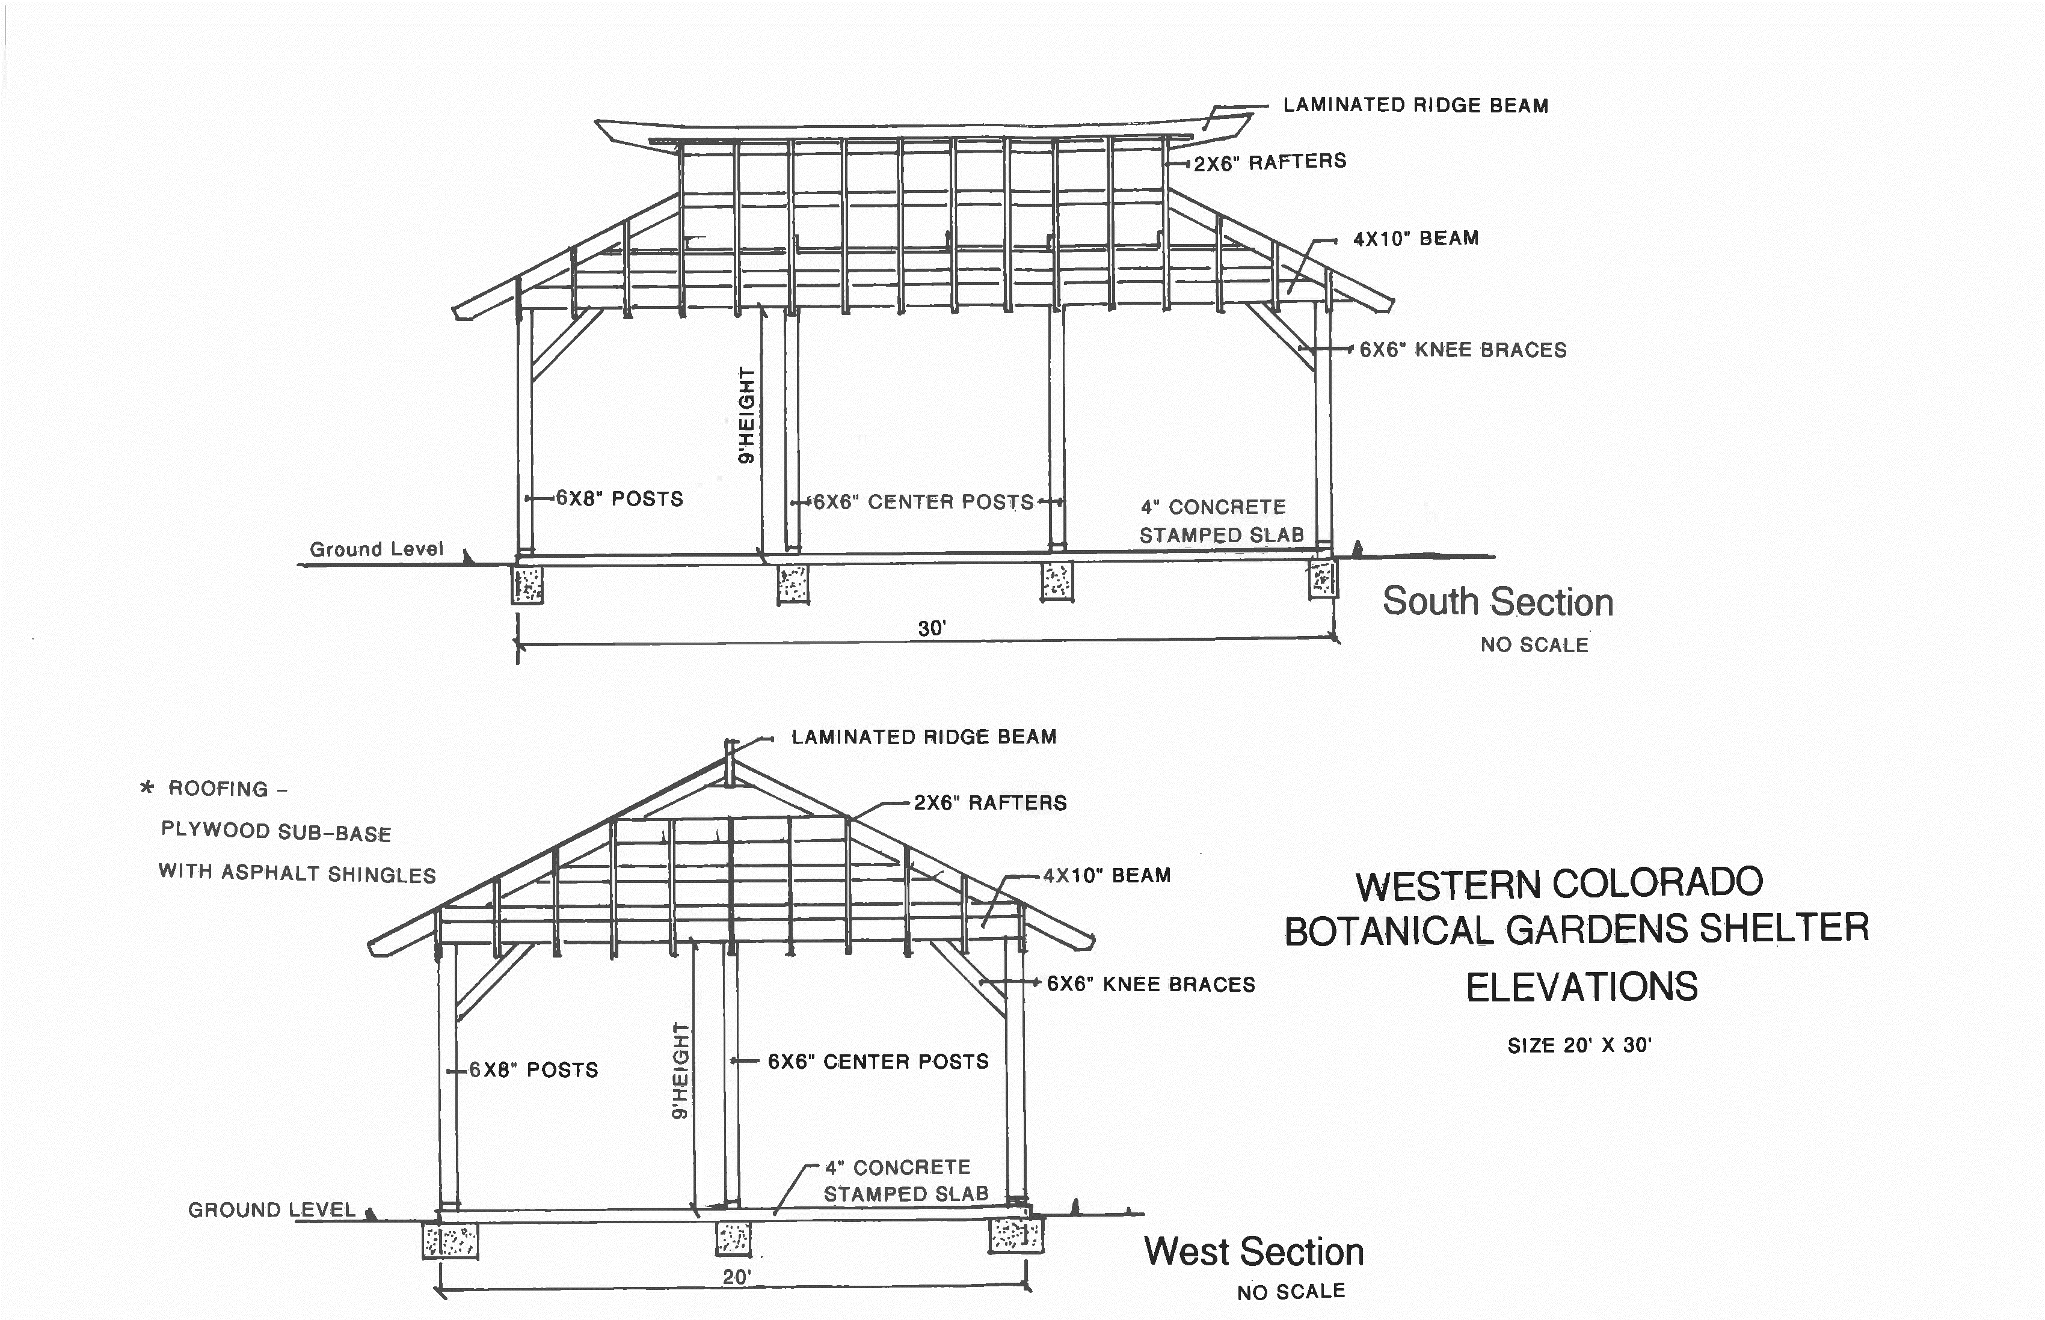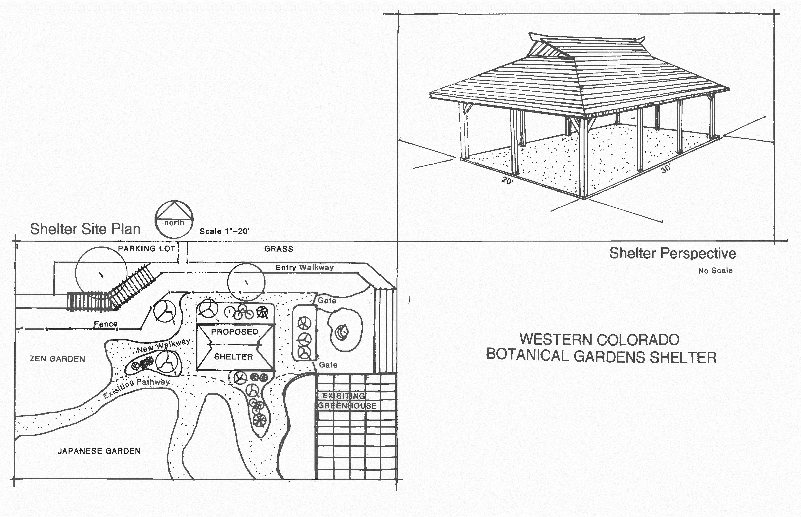
EXHIBIT B
EXHIBIT C
list of names not to be used in connection with the Gardens or the activities or programs associated therewith without the prior written consent of the Western Colorado Botanical Society:

Western Colorado Botanical Society
WCBS
Western Colorado Botanical Gardens
Western Colorado Botanic Gardens and Butterfly House
Bloomin’ Deals
Botanic Gardens Garden Tour
Sunset Stroll

